**Denagene Tajhiz Company**

**Biotechnology Lab Equipment manufacturer and designer**

Real-Time Electrophoresis

USER GUIDE

Real-Time Electrophoresis

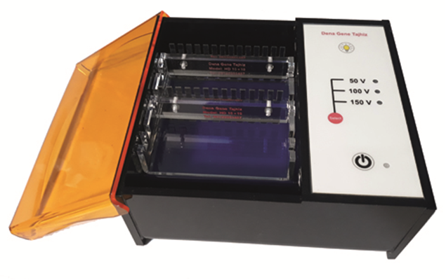

Thanks for choosing Denagene Tajhiz Real-Time Electrophoresis. This operation manual describes the function of the instrument. To ensure you can correctly operate the instrument, please read the manual carefully before using it. Please keep this manual properly for later use if you encounter any difficulty. The first time opening the packing, please check the instrument and appendix with the packing list. If anything does not match the packing list, don't hesitate to get in touch with us.

This manual serves as a valuable resource for all users of our products, whether you are a seasoned professional or just starting your scientific journey. It has been meticulously crafted to ensure that you clearly understand the features, functionality, and proper usage of our laboratory equipment.

Within these pages, you will find detailed instructions, diagrams, and troubleshooting guides that will assist you in harnessing the full potential of our products. We have taken great care to ensure that the content is organized logically, making it easy for you to navigate through the manual and locate the information you need quickly.

Moreover, this manual is a living document that reflects our ongoing commitment to excellence. As we continue to develop and improve our product offerings, we will provide updates and revisions to this manual to ensure that you always have the most up-to-date information at your fingertips.

Reproduction in any form, whether print or electronic, without written permission from Denagene Tajhiz Company, is strictly prohibited.

**Content**

Agarose Gel Electrophoresis

Safety Instruction

Care and Maintenance

Technical Specifications

Electrophoresis System Parts and Accessories

Agarose Gel Characteristics

Factors Influencing Nucleic Acid Migration in the Gel

Anomalous Migration

DNA Migration and Separation Mechanism

Electrophoresis Procedure

Preparation of the Gel

Loading the Samples

Initiating Electrophoresis

Staining and Visualization

Buffers

Applications

Problems with DNA Electrophoresis and Possible Causes

**Introduction**

Real-time electrophoresis is a specific model of horizontal electrophoresis system that is capable of performing all stages, from sample loading to result visualization, without the need for any additional devices. This system comprises three components: a horizontal electrophoresis apparatus, a power supply, and a transilluminator for DNA band visualization. The Midi model of horizontal electrophoresis is equivalent to a 10x10 horizontal electrophoresis system. The power supply is available in three voltage models: 50, 100, and 150 volts. Its transilluminator is part of the Safe Illuminator family and can also be used as a standalone transilluminator. The wavelength used in this system is 470 nanometers, which minimizes the need for device light to visualize DNA bands. It is worth noting that all DNA dyes, except Ethidium bromide, can be visualized with this wavelength. Furthermore, the power supply of this device is designed considering the key voltage requirements for electrophoresis.

Considering the precision of applied voltage (the device voltage accuracy is less than 1 volt) and the quality of observed bands, both of which are excellent, and taking into account the minimal space occupied in the laboratory, researchers and specialists are recommended to use this system to facilitate their research work as much as possible.

**Agarose Gel Electrophoresis**

Agarose electrophoresis is a type of gel electrophoresis used in the fields of biochemistry, genetics, and other subgroups of cellular and molecular sciences for separating various DNA, RNA, or protein sequences within a gel matrix created using agarose gel. Typically, the separation of biological molecules occurs by applying an electric field to this gel matrix. Agarose gels are easily moldable and are the most commonly used option for separating different types of DNA in the laboratory. The separated DNA can be visualized by staining it under appropriate light. Previously, ethidium bromide dye was used to visualize DNA bands, which required UV light for visualization. However, today there are various dyes available in the market with good quality and less mutagenicity compared to ethidium bromide, which can be visualized under visible light.

In the real-time electrophoresis systems of Denagene Tajhiz Company, the user is easily able to separate various nucleic acids. Agarose gels can be easily prepared using a suitable gel casting system. Denagene electrophoresis systems have been designed to provide high-quality usability for years.

**Safety Instruction**

* Before using the product, thoroughly read and understand this manual to ensure the correct use.
* Denagene’s real-time electrophoresis systems are designed for maximum safety and user-friendly operation.
* Before operating this apparatus, check that the tank chamber, power supply, and transilluminator are in good working condition.
* Due to the use of high voltage, it is essential to avoid the use of untrained individuals.
* Denagene Tajhiz Company does not accept responsibility for any damage caused to the device due to any unusual use or modifications made by unqualified individuals.

**Care and Maintenance:**

* The real-time electrophoresis chamber should be washed using a mild detergent solution in warm water.
* Take special care not to break or damage the electrode wire during cleaning.
* To preserve the longevity and lifespan of the device, use cleaning agents compatible with the equipment for cleaning purposes.

**The cleaning materials include:**

* Mild soap solutions and gentle detergents.
* Organic solvents such as hexane and aliphatic hydrocarbons.

**Note:** Do not leave plastic components in detergents for more than 30 minutes.

**Avoid using the following chemicals for cleaning the device as they can cause corrosion and damage the device components:**

"Chloroform, carbon tetrachloride, benzene, phenol, toluene, methyl ethyl ketone, acetone, methanol, ethanol, isopropyl alcohol."

* Do not expose the apparatus to temperatures above 60 degrees Celsius. Additionally, do not clean the apparatus with an autoclave.
* To eliminate RNase enzymes from the apparatus, treat it with hydrogen peroxide for 10 minutes, followed by washing it with 1/0% DEPS-treated water.

Note: the DEPC is a suspected carcinogen, so it is essential to strictly follow safety precautions when working with it.

**Technical Specifications**

|  |  |  |
| --- | --- | --- |
| **Mini Real-Time Electrophoresis** | **Midi Real-Time Electrophoresis** | **Model** |
| 7x7 cm | 7x10 cm  10x10 cm | Dimensions of Gel |
| 50 V | 50-100-150 V | Voltage Power |
| Up to 200 mA | Up to 200 mA | Flow |
| 15x19x7 cm | 17x23x7 cm | Dimension of Tank |
| 260-320 ml | 300-400 ml | Buffer Volume |
| 7 or 10 | 10 or 14 | Quantity of Sample ( Double-sided combs) |
| 20 | 42 | Maximum Quantity of Samples |

Technical Specifications of Real-Time Systems

**Electrophoresis System Parts and Accessories**

Below is a list of the components accompanying each model of the real-time electrophoresis system, along with their quantities:

* Electrophoresis tank: The tank is provided with a real-time electrophoresis system. As an example, the figure below shows the Midi model of the real-time electrophoresis system along with all the accompanying components.

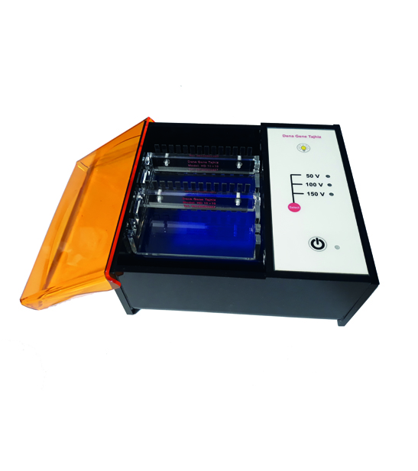

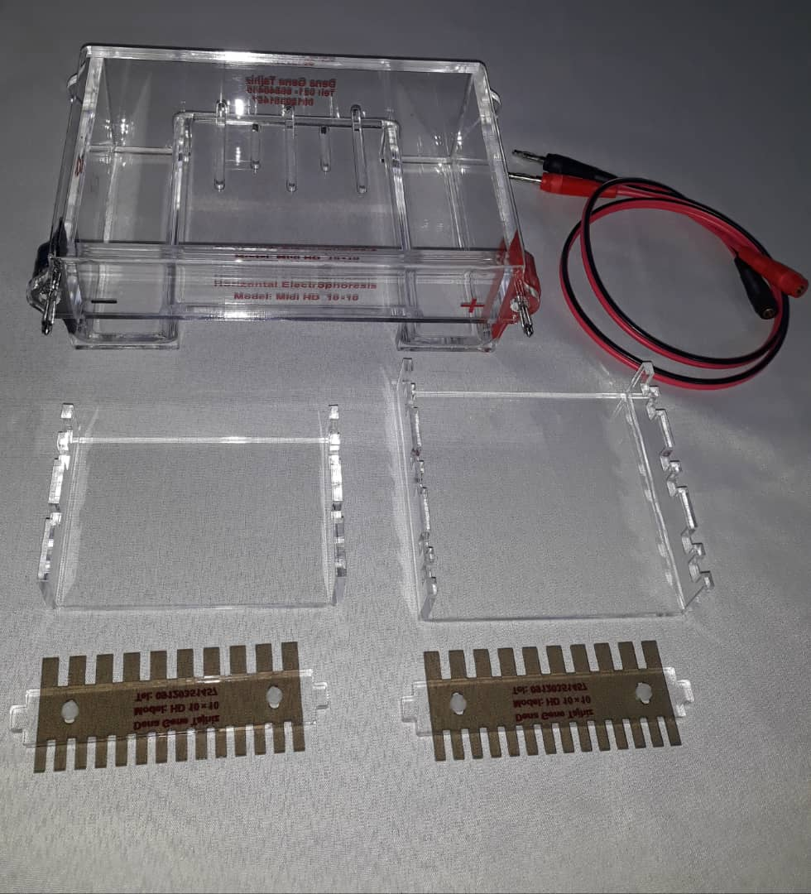

* Specialized combs: The figure below displays different sizes of combs for the real-time electrophoresis system. Each size corresponds to a specific model of the real-time electrophoresis system.

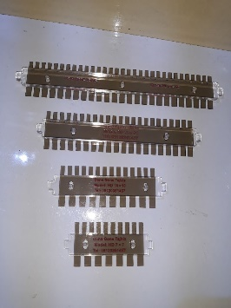

* Tray: Each model of the real-time electrophoresis system has its specific comb and tray. Additionally, the number of combs and trays can vary for each electrophoresis system.

The table related to the size and number of combs and trays of real-time electrophoresis models

|  |  |  |
| --- | --- | --- |
| **Comb** | **Gel Tray** | **Model** |
| One | 7x7 | Mini Real-Time |
| Two | 7x10 | Midi Real-Time |
| 10x10 |

Please note that the real-time electrophoresis system, unlike conventional electrophoresis systems, does not require external wiring connections. This is because the real-time electrophoresis system is equipped with an internal interface for connecting to the power supply system.

**Agarose Gel Characteristics**

Agarose gel is a three-dimensional matrix composed of helical agarose molecules. When arranged together, they create three-dimensional pores that are highly suitable for separating biomolecules. The entire three-dimensional structure is formed by hydrogen bonds, which can be disrupted by increasing the temperature. The gelling temperature of agarose is significantly different from its melting temperature. Depending on the source, agarose has a gelling temperature ranging from 35-42 degrees Celsius and a melting temperature of approximately 85-95 degrees Celsius.

Due to its large pore size and excellent gel strength, agarose gels are suitable convective media for the electrophoresis of DNA and large protein molecules. A 1% agarose gel typically has pores ranging from 100 to 300 nanometers. Lower concentrations of agarose result in very thin gels that are difficult to handle and move.

Compared to acrylamide, agarose gel has a larger pore size and lower resolution for DNA separation, but it offers a much wider separation range. The maximum separation range using this type of gel is approximately 750 kilobases, but the technique of pulsed-field gel electrophoresis (PFGE) is used for separations in the range of 6 Megabases. This technique is also applicable for separating large proteins and can efficiently separate particles with an effective radius greater than 5-10 nanometers. A 0.9% agarose gel is large enough to allow entry of the T4 Bacteriophage.

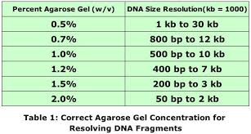

Figure 2. Different concentrations of agarose for separating DNA fragments of varying sizes.

Agarose polymer possesses a series of negative charges on the Sulfate and Pyruvate groups. These negative charges, through a process called electroendosmosis (EEO), induce the movement of water in the opposite direction of DNA migration. This phenomenon causes a delay in the movement of DNA molecules and subsequently affects their separation, resulting in weaker-formed bands.

**Factors Influencing Nucleic Acid Migration in the Gel**

Several factors can influence the migration of nucleic acids in gel electrophoresis: gel pore size (gel concentration), DNA fragment size, applied voltage, ionic strength of the buffer, and the concentration of DNA stain (such as DeNA Gel Stain) if added during electrophoresis. Smaller molecules move faster than larger ones in the gel, and double-stranded DNA migrates at a rate of 1/log of the number of base pairs in the gel. However, this relationship does not hold for very long sequences. Increasing the gel concentration leads to a decrease in the speed of DNA migration on the gel.

On the other hand, the conformation of DNA can also affect its movement on the gel. For example, supercoiled DNA exhibits faster mobility than relaxed DNA because supercoiled DNA is more compact and therefore moves more easily on the gel. The gel electrophoresis of plasmid molecules indicates a negative supercoiled state. However, nicked DNA molecules and relaxed circular forms appear as smaller bands.

DeNA Gel Stain, which binds to double-stranded DNA, can also affect the charge, length, and supercoiled conformation of DNA molecules, thus influencing the movement of DNA during electrophoresis. Agarose gel electrophoresis can be used for separating different types of DNA with various supercoiling topologies.

**Anomalous Migration**

* **Smiley gel**: This phenomenon occurs when the applied voltage for the gel concentration used is excessively high.
* **DNA smearing:** This leads to slow migration of DNA fragments.
* **Gel contamination:** The presence of impurities such as salts or proteins can affect the movement of DNA.

**DNA Migration and Separation Mechanism**

The negative charges of the phosphate backbone of the DNA molecule cause it to migrate towards the positively charged anode. It should be noted that in the absence of a gel matrix, the migration of DNA molecules is independent of their molecular weight and size. Therefore, it can be said that the role of the gel matrix is to separate DNA based on size during electrophoresis.

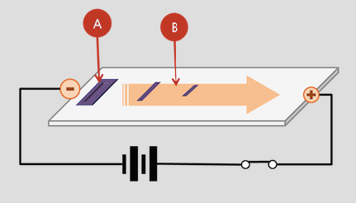

Figure 3. General schematic of electrophoresis process and direction of nucleic acid movement.

**Electrophoresis Procedure**

The electrophoresis process consists of several consecutive steps, summarized as gel preparation, sample loading, initiation of electrophoresis, and finally, result visualization. Below is a detailed explanation of each step.

**Preparation of the Gel**

Agarose gel can be prepared by dissolving agarose powder in a suitable buffer, such as TAE or TBE. The agarose powder is first dissolved in the desired buffer and then heated close to boiling temperature, but care should be taken not to boil it. The melted agarose should be cooled sufficiently before pouring it into the gel tray. If the temperature is too high, the gel tray may become damaged.

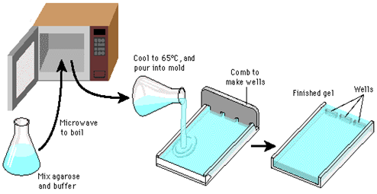

Figure 4. Schematic of the steps involved in agarose gel preparation.

Place the gel comb in the gel tray before pouring the melted agarose to ensure the proper formation of loading wells. A 1% gel concentration is typically prepared for routine electrophoresis.

**Loading the Samples**

Once the gel is sealed, remove the comb and now you can load the samples by placing the gel tray in the tank chamber and pouring enough fresh buffer. It is important to mix the samples with a loading buffer before loading them into the wells. Typically, a loading buffer consists of a high-density solution such as glycerol, sucrose, or Ficoll, which increases the overall density of the samples, allowing the DNA samples to easily settle at the bottom of the wells. The loading buffer also contains dyes such as xylene cyanol and bromophenol blue. These dyes are used to visualize the progress of the samples on the gel being used (commonly referred to as Tracing Dyes). Now, load the DNA samples using a pipette.

**Initiating Electrophoresis**

Agarose gel electrophoresis is typically performed in submarine electrophoresis systems where the gel is submerged in a buffer during the electrophoresis process. The gel can also be run in a vertical electrophoresis system, although this method is less commonly used for agarose gel electrophoresis.

It should be noted that higher voltage will result in faster separation of samples, but it can also lead to gel melting and buffer depletion, compromising the quality of sample separation. Conversely, a lower voltage can cause band broadening for small DNA fragments. Since DNA molecules are not visible under normal light, dyes are loaded along with them. Xylene cyanol (light blue) migrates with larger DNA molecules, while bromophenol blue (dark blue) migrates with smaller DNA fragments.

Furthermore, during sample loading, a DNA marker is also added to a separate well. This marker contains fragments of DNA molecules with specific weights, which are used to estimate the weights of DNA molecules. It should be noted that the migration of circular DNA molecules (such as plasmids) is different from the migration of linear DNA molecules, and their weights cannot be estimated accurately using standard markers. Therefore, it is necessary to linearize them using specific restriction enzymes before running them on the gel.

**Staining and Visualization**

DNA and RNA molecules in real-time electrophoresis can be stained with all colors except ethidium bromide. The dyes that can be used for coloring and visualization in real-time electrophoresis include DNA Gel Stain, SYBR Green, GelRed, and dyes from the safe dye family. The table below lists more of the dyes used in real-time electrophoresis.

Note: If your research center or laboratory uses a specific dye that is not listed here, it is recommended to consult with the company for better assurance before purchasing.

The Ames test indicates mutagenic (mutation-causing) potential. To visualize the samples using SYBR Green, it is necessary to use a transilluminator with blue light. With the guidance of the coloring instructions using the dyes provided in the figure below, users can use all the safe dyes produced today. Additionally, Denagene Tajhiz Company has also developed a specific dye that falls into the safe dye category based on Ames-test results, and it is marketed under the trade name DeNA gel stain. This dye has provided the best results with real-time electrophoresis equipment. Therefore, researchers and specialists are recommended to use this dye for visualizing DNA bands, considering its reasonable price and high quality.

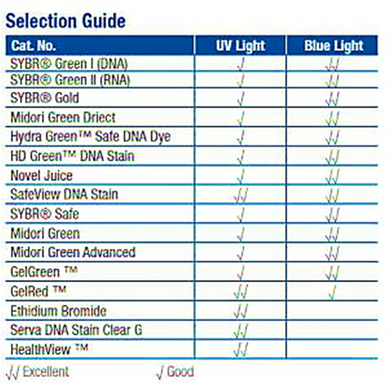

Figure 5. List of dyes that can be used in real-time electrophoresis.

**Buffers**

The net charge of biological macromolecules is highly dependent on the environmental PH. To minimize pH changes induced by the electric field, electrophoresis is performed in a buffered environment. Ideally, a buffer should have high conductivity, generate less heat, and have long-term stability. Some buffers used for agarose gel electrophoresis to separate nucleic acids include Tris-acetate-EDTA (TAE) and Tris-borate-EDTA (TBE). Other buffers are also used but have much less application compared to the mentioned two buffers. Tris buffer has a high buffering capacity, but if the extracted DNA is used in a reaction sensitive to phosphate, it cannot be used. TAE buffer has the lowest buffering capacity but provides excellent resolution for large DNA molecules. Buffers containing EDTA are typically used to deactivate various nucleases that require divalent cations for their activity. If separation at the double-stranded level is required, a gel with 3% agarose and a medium with extremely low conductivity created by 1 millimolar lithium borate buffer should be used. If buffers are used for an extended period, their buffering capacity will decrease, and they may no longer provide the necessary environment for electrophoresis.

**Applications**

* Estimation of the size of DNA molecules after digestion with restriction enzymes, such as mapping cloned DNA after exposure to restriction enzymes.
* Visualization of different DNA bands.
* Analysis of PCR products, for example, in genetic diagnostics or genetic fingerprinting.
* Separation of DNA fragments for extraction and purification.
* Separation of fragmented genomic DNA before Southern blotting or RNA before Northern blotting.

Agarose gels are easily moldable and movable, and nucleic acids do not undergo any chemical reactions with them. Samples can be easily located in the gel. After the experiment is completed, the obtained gel can be placed in a nylon membrane and stored in the refrigerator.

**Problems with DNA Electrophoresis and Possible Causes**

**1- Low intensity of all or some DNA bands**

Possible reasons:

Low loading of DNA ladder.

Insufficient or uneven staining.

DNA leakage from the gel.

DNA diffusion and spreading in the gel.

DNA masking by the dyes used for staining.

**2- Smearing of the bands.**

Possible reasons:

• DNA degradation by nucleases.

• Inappropriate electrophoresis conditions.

• Gel shift effect.

• Overloading of DNA.

• High salt concentration in the sample.

• Improper well formation in the gel.

**3- Unusual band patterns.**

Possible reasons:

• Failure to heat the DNA marker before loading.

• DNA Denaturation

• Different loading conditions for the sample DNA and the marker DNA.

• Inappropriate electrophoresis conditions.

• Incorrect gel percentage or buffer used.

• Anomalous migration due to DNA sequences or structures.

• Gel shift effect.

• High salt concentration in the samples.

**4- Curved-shaped DNA bands.**

Possible reasons:

• Incomplete placement of the gel in the electrophoresis buffer.

• Low sample volume.

• Inappropriate electrophoresis conditions.

• Presence of bubbles or large particles in the gel or wells.

**5- DNA remaining in the gel.**

Possible reasons:

• Improper well formation in the gel.

• Overloading of DNA.

• Contaminated DNA sample.

• Gel shift effect.

**6- Incorrect quantification.**

Possible reasons:

• Different loading conditions between the marker DNA and the samples.

• Wrong band selection for quantifying the sample.

• Use of an inappropriate quantification method.

• Uneven gel staining and background coloration can affect gel quantification results.

• DNA masking by tracking dyes.

**7- Anomalous migration.**

• gel smiley

•Excessive pouring of DNA.

• Gel contamination: Presence of impurities such as salts or proteins that can cause movement.

Documentation and Support

To obtain support for the latest services and support information for all locations, go to:

[www.Denagene.com](http://www.Denagene.com)

At the website, you can:

• Access worldwide telephone and fax numbers to contact Technical Support and Sales facilities

• Search through frequently asked questions (FAQs)

• Submit a question directly to Technical Support

• Search for user documents, SDSs, vector maps and sequences, application notes, formulations, handbooks, certificates of analysis, citations, and other product support documents

• Obtain information about customer training

• Download software updates and patches