**Denagene Tajhiz Company**

**Biotechnology Lab Equipment manufacturer and designer**

UV Transilluminator

User Guide

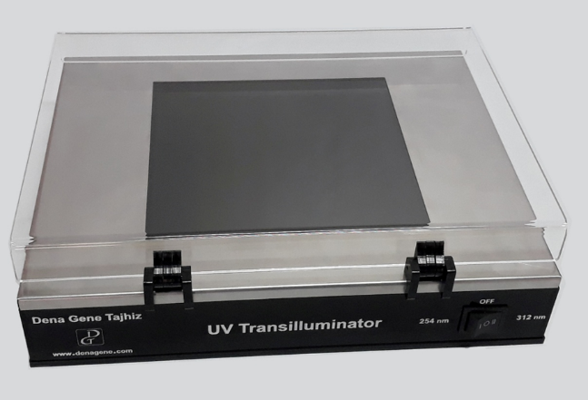

Thanks for choosing The Denagene Tajhiz Company’s UV Transilluminator. This operation manual describes the function of the instrument. To ensure you can correctly operate the instrument, please read the manual carefully before using it. Please keep this manual properly for later use if you encounter any difficulty. The first time opening the packing, please check the instrument and appendix with the packing list. If anything does not match the packing list, don't hesitate to get in touch with us.

This manual is a valuable resource for all users of our products, whether you are a seasoned professional or just starting your scientific journey. It has been meticulously crafted to ensure that you clearly understand the features, functionality, and proper usage of our laboratory equipment.

Within these pages, you will find detailed instructions, diagrams, and troubleshooting guides that will assist you in harnessing the full potential of our products. We have taken great care to ensure that the content is organized logically, making it easy for you to navigate through the manual and locate the information you need quickly.

Moreover, this manual is a living document that reflects our ongoing commitment to excellence. As we continue to develop and improve our product offerings, we will provide updates and revisions to this manual to ensure that you always have the most up-to-date information at your fingertips.

Reproduction in any form, whether print or electronic, without written permission from Denagene Tajhiz Company, is strictly prohibited.

Content

Introduction

UV Transilluminator

Set up and Installation

Safety Instructions

Technical Specifications

UV Transilluminator Features

Applications

Warranty

**Introduction**

After completing the electrophoresis process, it is necessary to examine the results related to DNA bands. The transilluminator apparatus is the simplest method for visualizing DNA bands. Usually, during the electrophoresis process, DNA is stained with an external fluorescent dye that is excited by a specific wavelength. Therefore, considering the excitation wavelength of the dye used in the electrophoresis process, one can select the desired transilluminator device. To meet the needs of researchers and specialists, Denagene Tajhiz Company has designed and manufactured all models of transilluminators. Especially, the UV transilluminator models that have the most applications for detecting DNA and RNA bands. Denagene is the designer and manufacturer of various models of UV transilluminator apparatus. In all models of UV transilluminators, a stainless body cover has been used to control UV radiation precisely.

A transilluminator, also known as a UV transilluminator, is an apparatus used in molecular biology laboratories to visualize DNA and RNA bands in gel electrophoresis. After performing the electrophoresis procedure, observing the formed bands is a crucial step for making decisions regarding the subsequent stages of research. The simplest way to visualize these bands is by using a transilluminator device.

**Set up and Installation**

The usage of this device is extremely simple. To observe gels, first place the gel tray containing the gel onto the filter part of the device. Lower the UV radiation protective cover. Then proceed to turn on the device. The bands will be visible. However, it is important to note that the excitation wavelength of the dye used should be in significant overlap with the emitted wavelength of the device. Therefore, selecting the appropriate dye is of high importance. After observing the bands, it is better to turn off the device promptly to minimize DNA damage from UV radiation exposure.

**Safety Instructions**

• Due to the hazards associated with UV light, it is essential to always place the UV radiation protective cover on the device before using it, and then proceed with observing the samples.

• When using dyes for DNA staining, it is important to consider that all of them, especially ethidium bromide, have a high carcinogenic potential. Therefore, maximum safety precautions should be taken regarding their handling.

• In case of any issues with the device, do not attempt any curious actions to repair it. Instead, inform the personnel of the Denagene Tajhiz Technical Team immediately for prompt assistance.

**Technical Specifications**

|  |  |  |  |
| --- | --- | --- | --- |
| Technical Specifications | | | |
| 254 TRS | 312 TRS | TRD | Model |
| nm 254 | nm 312 | 312&254 nm | Wavelength |
| mm 200x200 | mm 200x200 | 200*200 mm | Filter Sizes |
| 100*300*360 mm | 100*300*360 mm | 100*300*360 mm | External dimensions (height *width *length) |
| 3.5 kg | 3.5kg | 3.5kg | Weight |

**Features:**

• Stainless steel body, corrosion-resistant and durable.

• Equipped with UV lamp.

• Uniform UV light intensity across the filter.

• Possibility to order custom wavelengths.

• Safe and reliable design.

**Applications**

• Estimation of the size of DNA molecules after digestion with restriction enzymes.

• Analysis of PCR products.

• Genomic DNA separation before Southern blotting or RNA separation before Northern blotting.

**Warranty**

• The transilluminator device manufactured by Denagene Tajhiz Company comes with a one-year warranty for its components.

• Breakable items and lamps are not covered by the warranty, as per common practice.

• The transilluminator device manufactured by Denagene Tajhiz Company is accompanied by 10 years of after-sales service.

**Documentation and Support**

To obtain support for the latest services and support information for all locations, go to:

[www.Denagene.com](http://www.Denagene.com)

At the website, you can:

• Access worldwide telephone and fax numbers to contact Technical Support and Sales facilities

• Search through frequently asked questions (FAQs)

• Submit a question directly to Technical Support

• Search for user documents, SDSs, vector maps and sequences, application notes, formulations, handbooks, certificates of analysis, citations, and other product support documents

• Obtain information about customer training

• Download software updates and patches

Contact Us:

[info@denagene.com](mailto:info@denagene.com)‌